1.Program for fibanocci recursion and itreative

#include <stdio.h>

int fibonacci(int n) {

if (n <= 1) {

return n;

} else {

return fibonacci(n - 1) + fibonacci(n - 2);

}

}

int main() {

int n;

printf("Enter the number of terms: ");

scanf("%d", &n);

printf("Fibonacci series using recursion: ");

for (int i = 0; i < n; ++i) {

printf("%d ", fibonacci(i));

}

printf("\n");

return 0;

}

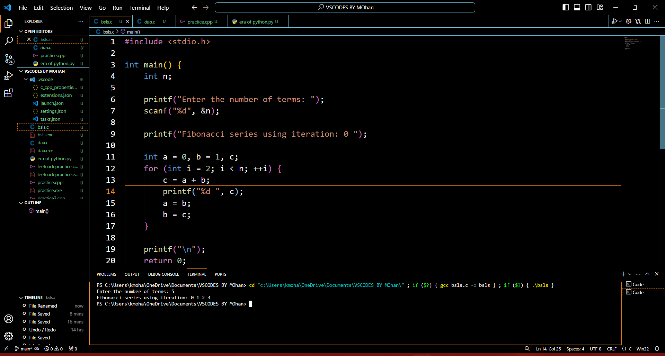

#include <stdio.h>

int main() {

int n;

printf("Enter the number of terms: ");

scanf("%d", &n);

printf("Fibonacci series using iteration: 0 ");

int a = 0, b = 1, c;

for (int i = 2; i < n; ++i) {

c = a + b;

printf("%d ", c);

a = b;

b = c;

}

printf("\n");

return 0;

}